Appendix A  
  
Data Inventory and Gaps Analysis

Background

SWCA Environmental Consultants (SWCA) conducted a data inventory and gaps analysis to be used for the Larimer County Water Plan (plan). This analysis, consisting of an initial review of available data, resulted in a compilation of studies, data, and descriptive information specific to Larimer County’s geography, climate, water infrastructure, floodplains, susceptibility to natural hazards, and existing watershed and community planning resources within Larimer County. This memorandum identifies and qualifies the impacts of missing or incomplete data on the Larimer County Water Plan and makes recommendations for addressing data gaps.

Methodology

SWCA sought data sources based on recommendations from the County Core Team, the Water Advisory Group (WAG), and Technical Advisory Group (TAG). The project team, composed of SWCA and AE2S staff, worked collaboratively to obtain relevant data from publicly available sources such as the Colorado Department of Public Health and Environment (CDPHE), the U.S. Geological Survey’s (USGS’s) National Hydrography Dataset (NHD), USGS, Colorado’s Decision Support Systems, and Colorado Division of Water Resources. Additional coordination with the Core Team and TAG members yielded data sets that were not publicly available. The Core Team is composed of representatives from different Larimer County departments and offices including Community Development; Engineering; Natural Resources; Planning; and Office of Emergency Management. The TAG is comprised up of experts and/or professionals such as water managers, who provide guidance, advice, and recommendations on technical matters related to water use and conservation. The WAG is comprised of groups and organizations involved in the planning process.

The project team reviewed all data sets for their relevance to the project, including geographic extent and data resolution. SWCA provided the County Core Team with an initial data table, which contained the review of available data sources and of their relevance to project analyses, described available data sources, and identified additional data needs. The County Core Team then provided feedback, ranked datasets based on relevance to the plan’s vision and goals, and provided direction to potentially fill identified data gaps. We contacted project stakeholders for information on specific data needs and location where required. The County Core Team and stakeholders sent data sources or links directly to SWCA contacts, or uploaded data sets to the shared project site.

Results and Recommendations

Table A-1 lists data gaps that still exist, discusses any implications to the plan and provides recommendations for addressing persistent gaps. Attachment A includes a full list of data sets considered for this project. Table A-1 also discusses instances where data were available but lacked local detail or did not cover the entire planning area. The project team will use proxy data sources where possible to represent the respective data category as accurately as possible (see the Proposed Approach Recommendations).

Table A-1. Planning Area Data Gaps

| Data Gap | Implications | Proposed Recommendations |
| --- | --- | --- |
| **Decreed water rights** | Specific information related to decreed water rights, such as water amount, is not available. Colorado’s Decision Support Systems includes information on active and unmaintained diversion records that provide sufficient information on diversion location. Data may not accurately reflect actual annual water diversion amounts for each water decree. | The project team will use Colorado’s Decision Support Systems data to assess the location and active status of ditches, pipelines, and pumps in the planning area. The analysis may lack water quantity information for each water decree. |
| **Fuel Reduction Efforts** | Although many groups are performing fuel reduction activities, there is not common dataset that is actively being updated to track historic and ongoing efforts. This made it impossible to include in mapping analysis of the plan | The project team recommends creating a common interagency dataset to help track fuel reduction activities. Stakeholders of the Water Plan commented that CFRI has started this effort. |
| **Irrigated Lands Dataset** | The irrigated lands dataset exists but hasn’t been updated since 2020 and seems to only be updated infrequently. Having a more complete record would help us see clear trends in urban growth and loss of irrigated lands. Because the data is incomplete, we will focus more on the proximity of irrigated lands to urban development and traffic, rather than tracking areas where urban developments has recently converted irrigated land. | Ask the data supplier (Colorado Decision Support System) to create a new dataset for this either annually or biannually to better understand long term trends in agricultural land to urban development conversion. |
| **Climate Impact Data for Larimer River Basin** | The water supply climate impact data acquired from the City of Fort Collins and the City of Greeley’s Water supply plans provided insight to climate impacts for almost the entire county with the exception being the Laramie River Basin. Without data for this basin, the mapping exercise assumed that this basin had no adverse impacts due to climate. This had very little implications for the plan results. | Recommend speaking with downstream users of the Laramie River Basin to see if any climate impact data is available. If not, suggest they consider studying it. |
| **Long Term Spatial Population Growth Projections** | Although long term population values are available for the entire county and its largest municipalities, no spatial dataset indicates where we expect that growth to occur. The implications for this are minor as it isn’t pivotal to the plan, however, developing a long-term growth spatial dataset could provide valuable insight. | No immediate recommendation but this dataset would be valuable if developed in the future. |
| **Interconnections Between Water Systems** | It was difficult to find a single dataset that showed/explained all of the interconnections that exist between water systems. This made it difficult to understand redundancy and vulnerabilities between various water providers | Recommend developing this dataset in the future, potentially as part of an education initiative. |

*This page intentionally left blank.*

Exhibit A1  
  
Comprehensive List of Data Sets

Table Ex.A-1. Comprehensive List of Data Sets

| Data Type | Dataset Name or Description | Data Information | Data Source |
| --- | --- | --- | --- |
| **Decreed water rights** | Colorado’s Decision Support System Decreed Features | Includes ditches, ditch systems, pipelines, and pumps with a use code of A (active structure with contemporary diversion records) or U (active structure without maintained diversion records) | Colorado’s Decision Support Systems |
| **Aquatic resources** | Colorado Parks and Wildlife (CPW) aquatic management waters data | Aquatic Sportfish Management Waters (ASMW), Aquatic Native Species Conservation Waters (ANSCW), Aquatic Gold Medal Waters (AGMW), Aquatic Cutthroat Trout Designated Crucial Habitat (ACTDCH), and aquatic species of greatest conservation need (SGCN) | CPW |
| **Wetland and riparian areas** | NHD/National Wetland Inventory | NHD location and composition of wetlands | USGS and U.S. Fish and Wildlife Service |
| **Abandoned and Active mining lands (AMLs)** | Division of Reclamation, Mining and Safety (CDRMS) map | Location, age, and type of abandoned mine lands | CDRMS |
| **5-year Spatial Population Growth Projections** | ESRI Demographics 5-year Population Growth Projection (by quarter section) | Data obtained through ESRI Demographics database | ESRI Demographics |
| **Parcel data** | Larimer County Parcel Data | Information on county parcels (boundary lines, area, etc.) | Larimer County Website |
| **Septic Tank Locations** | Septic Tanks | Location of Septic Tanks in Larimer County | Larimer County Website |
| **Zoning Data** | Larimer County Zoning | Zoning layers for unincorporated and incorporated Larimer County | Multiple (Larimer County Website, Fort Collins, Loveland, Wellington, Timnath, Winsor, Estes Park & Berthoud Websites |
| **Wildfire Susceptibility Data Layer** | CWCB Wildfire Ready Susceptibility to Water Infrastructure Layer | Scored watersheds indicating potential impacts to water infrastructure due to wildfire | CWCB Wildfire Ready |
| **Hydrologic Unit Code (HUC) 12 Watershed Layer** | HUC12 Watershed Layer | Watershed boundaries, names, and areas for entire county. | USGS Watershed Boundary Dataset |
| **Underground Oil Tanks** | Underground Storage Tanks | Locations of all active and abandoned underground petroleum/oil storage tanks | Colorado State Forest Service; State of Colorado, Department of Labor & Employment, Division of Oil & Public Safety |
| **Stream Flow Lines** | Stream Flow Lines from National Hydrography Dataset | Stream flow line spatial data | USGS National Hydrography Dataset |
| **303D Impaired Waters Data** | Stream Segmentation, Impaired Waters | Complete Colorado 303D list showing impairments on every major stream segment in the county. | CDPHE |
| **Climate Sensitivity Data** | Water Source Sensitivity to Temperature | Information on potential impacts to water supply based on a four degree increase in average daily temperatures | Greeley Integrated Water Supply Plan and Fort Collins Water Supply Vulnerability Study |
| **Threatened and Endangered Species Habitat Areas** | Threatened and Endangered Species Habitat Areas | Spatial Layer showing habitat locations of threatened and endangered species | CPW |
| In Stream Flow Dataset | ISF Locations | Locations where in stream flow rights exist | CWCB |
| Colorado Big Thompson Contract Allotment Data | Colorado Big Thompson Contract Allotment Data | Information on Colorado Big Thompson Share Allocations | Northern Water Conservancy District |
| EJScreen Community Layers | EJScreen Community Layers | Location and information on vulnerable communities within the county | EPA |
| EPA Water System Database | Water System Data | Information on every water system in the county including, number of service connections | EPA |
| Larimer County Existing Conditions Report | Larimer County Existing Conditions Report | Various GIS datasets including water provider service areas | Larimer County (2022 Brendle Group) |
| Larimer County Boundary and Extent Layers | Larimer County Boundary | Larimer County Boundary | Larimer County Website |

Appendix B  
  
Challenges, Influencing Factors, and Focus Areas

Overview

This appendix includes further details and descriptions for each of the factors that the county and its stakeholder groups selected for the six challenges shown in the graphic below. It also includes a table of the data that the county used in the mapping analysis as well as the analysis results showing the different focus areas for the Supply and Demand Planning, Watershed Health, Water Rights, and Water Infrastructure challenges (see Exhibits B2 – B5). Finally, it includes a list of example policies, initiatives, and programs related to Water Conservation and Water Education that members of our engagement groups are currently involved in (see Exhibits B6 and B7).

Each of these challenges and their contributing factors, including their meaning and importance, are explained in the next section.

Descriptions of Challenges and Their Contributing Factors

As the environment and communities change, these changes can affect our water supply. To safeguard enough water for the future and support healthy community growth, water leaders plan for these changes. The county identified three key factors for this challenge:

* 1. **How the population may change and impact water demand.**
  2. **How the climate may change and impact water supply & demand.**
  3. **How the way people us the land may change and impact water demand.**

The county focused on growing communities with this challenge because expanding populations and changing land use can impact water needs. More people and homes may require more water, and some land use types make it difficult to predict water consumption. The county also used studies from the City of Greeley and the City of Fort Collins to assess how rising temperatures might reduce future water availability. This information helps the county ensure that community growth matches the amount of water available. **Table B-1** shows the factors the county studied, as well as their meaning and importance.

Table B-1. Factors selected to investigate water Supply and Demand Planning in Larimer County.

|  |  |  |
| --- | --- | --- |
| Factor | What It Means | Why It’s Important |
| Increasing Demand from Population Growth | How much will the population grow? | Areas where the population grows the most may need more water in the future. |
| Uncertain Water Future as it Relates to Climate | How much water will be available if the temperature rises | Helps find areas where there might be less water available in the future due to rising temperatures. |
| Land Use Changes | What is the land being used for? Stores, factories, homes, farming? | Find out where there are types of land use that are difficult to estimate how much water the owner may use (farms, businesses, and factories). |

The health of a watershed is very important because every drop of water that flows through it touches the ground and might pick up dirt or pollution along the way. This water eventually becomes our drinking water, so it’s crucial to do all we can to keep it clean. We also rely on this water for fun recreational activities and protecting local wildlife habitats. This challenge focused on the following three factors:

* 1. **Wildfires with high burn severity and the threat they pose to our water.**
  2. **Things that could impact the quality of our water.**
  3. **Threats to local wildlife habitats including urban encroachment and insufficient stream flow.**

This part of the plan examines how wildfires, pollutants, and expanding communities can affect people, animals, and water. Wildfires can destroy vegetation that holds soil in place, causing erosion and making water treatment more difficult. Pollutants are also a concern, so it’s important to monitor areas near factories, homes, and farmland to keep the water clean. This also helps protect natural areas and wildlife. **Table B-2** shows the factors the county looked at, as well as their meaning and importance.

Table B-2. Factors selected to investigate Watershed Health in Larimer County.

|  |  |  |
| --- | --- | --- |
| Factor | What It Means | Why It’s Important |
| Wildfires with High Burn Severity | How wildfires could harm people, homes, and water supplies. | Identifies areas where wildfires have a greater chance to impact our water supply. |
| Source Water Quality | How clean or dirty the water is. | Identifies areas near oil tanks, mines, or factories that could pollute the water. |
| Habitat | Where animals live and how their homes are affected by water. | Identifies areas with important wildlife and if anything could be harming their habitat. |

Water rights are legal claims to specific amounts of water. In Colorado and Larimer County, this issue is complex, as rules and the monetary value of water can significantly affect how much water is readily available. The county reviewed three key factors to understand this challenge better:

1. **Where and how often are people being affected by water right rules when there isn’t enough water for everyone.**
2. **How the Colorado Big Thompson Project helps with water supplies and where people are using the water.**
3. **How cities are expanding into surrounding farmland.**

Examining where shortages interrupt water use helps identify areas with less reliable water. This assists the county in community planning, water resource management, and promoting efficient water use. The Colorado Big Thompson Project is a very important source of water in the county. For more information on this delivery system, please refer to the [Northern Water Conservancy District Colorado-Big Thompson Project Website](https://www.northernwater.org/what-we-do/deliver-water/colorado-big-thompson-project/cbt-infrastructure). Understanding city expansion into farmland also allows the county to engage with landowners to discuss how they can help protect their land from development pressures when it’s appropriate. **Table B-3** outlines the factors the county selected, their definition, and why they are important

Table B-3. Factors selected to investigate water rights in Larimer County.

|  |  |  |
| --- | --- | --- |
| Factor | What It Means | Why It’s Important |
| Water Rights Impacted by Administrative Calls on the River | How often was the ability to use water affected by water rights rules since 2000. | Identifies what locations were impacted the most by water rights rules in the last 25-years. |
| Use of Water from the Colorado Big Thompson Project | How much water is being used from the Colorado Big Thompson Project. | Identifies areas where water from the Colorado Big Thompson Project is being used. |
| Urban Encroachment on Agricultural Lands | Shows where cities are expanding into irrigated lands and how much traffic is in the area | Helps find areas where city expansion and traffic growth could interrupt farming operations and make work inconvenient for landowners. |

Water infrastructure consists of pipes, reservoirs, and systems that deliver water to people. Over time, these systems need expensive maintenance and replacement, especially as communities expand and require larger pipes and upgrades. The county investigated the following factors for this challenge:

1. **How many small water systems there are.**
2. **How many mobile home parks get water from private systems.**
3. **How many places, like homes and businesses, are connected to the water system.**
4. **How much water is being stored in and upstream of a watershed.**

This information helps the county collaborate with water providers to ensure systems run smoothly and meet future needs. It also helps identify smaller water systems, allowing the county to coordinate with them and other providers as they manage growth, increasing costs, and legal requirements. **Table B-4** outlines the factors the county studied, their meaning, and why they are important.

Table B-4. Factors selected investigate water infrastructure in Larimer County.

|  |  |  |
| --- | --- | --- |
| Factor | What It Means | Why It’s Important |
| Water Delivery Infrastructure | How many water systems are there and how big of an area do they serve. | Smaller water systems (i.e. serve <10,000 people) that cover large service areas may be underfunded. |
| Thoughtful Storage | Amount of water that can be stored in and upstream of a watershed. | Find areas where there is less storage relative to others. |

One of the best ways to protect our water is by using it wisely. Many communities have policies or provide tips for reducing personal water use, which can significantly support smart and sustainable growth. The county investigated the following factors for this challenge:

1. **What are some effective resources for promoting water efficiency practices within a community?**
2. **What are some effective land use and landscaping policies that help reduce water usage?**

For this challenge we collected examples of good water efficiency practices, guidelines, and landscaping codes that other communities have developed. This information will be a great reference for the county as it considers how it can best promote water efficiency throughout the community. **Table B-5** shows the factors the county studied, their meaning, and why they are important.

Table B-5. Factors used to look into Water Conservation in Larimer County.

|  |  |  |
| --- | --- | --- |
| Factor | What It Means | Why It’s Important |
| Water Efficiency Practices | Things communities are doing to help conserve water (i.e. building code updates that require efficient toilets, facets, shower heads, watering restrictions, etc.) | The county can learn from the current best practices and apply/promote the ones that they believe will work best for our community. |
| Landscaping and Land Use Policies | Policies and codes that other communities are using to limit the amount of water needed to maintain landscapes around new businesses and homes. | The county can learn from these examples and apply/promote the practices that will work best for our community. |

Learning about water and how it’s managed in the county helps all county residents work together and make a greater impact. Education also clarifies the roles of different entities in protecting our water. the county investigated the following topics for this challenge:

1. **What efforts/programs exist to help educate the public on water related topics**
2. **What efforts/programs exist to help educate water leaders and government officials on water related topics.**
3. **What education resources are available and how can we make them more accessible.**

The county conducted one-on-one discussions with several engagement group members to learn about the local water programs and initiatives they are involved in, focusing on opportunities to engage leadership and the public. The county also compiled an inventory of available resources that they can refer others to and promote, aiming to build on existing efforts. **Table B-6** provides details on the factors the county selected, their meanings, and why they are important.

Table B-6. Factors used to look into Water Education efforts in Larimer County.

|  |  |  |
| --- | --- | --- |
| Factor | What It Means | Why It’s Important |
| Public Education | Educating the public about water including programs focused on K-12 education. | The public has a huge part to play in protecting our water. Education for children and adults leads to better decisions and more passionate and informed communities |
| Leader and Government Education | Educating water leaders and decision makers on best practices, industry trends, and local needs. | Local leaders in water and government have a huge influence on how reliable our water supply is and will be in the future. Programs to keep them informed help them make important decisions in an informed manner. |
| Existing Education Resources | Promoting and supporting existing materials, resources and programs that are already making an impact | There are a lot of ongoing efforts to help educate the county’s communities on water related topics, the more that can be done to strengthen these efforts and extend their reach the better. |

Exhibit B  
  
Data Collected and Mapped to Identify Focus Area

**Exhibit B1**

Presents the data the county used to score and determine Focus Areas for challenges one through four. The mapping results for these challenges are displayed in Exhibits B2 through B5.

Table Ex.B1-1. Challenges Related to Supply and Demand Planning and Data Used

|  |  |  |  |  |  |
| --- | --- | --- | --- | --- | --- |
| **Challenge** | **Factor** | **Metrics** | **Why it Matters** | **Methodology** | **Datasets** |
| **Supply & Demand Planning** | Increasing Demand from Population Growth | Projected Population Increase (2023-2028) | Growing areas may need more water. | Used Esri Demographics (Projected Population Growth 2023-2028) for each county quarter section. | Esri Demographics |
| Uncertain Water Future as it Relates to Climate | Impact on water availability due to rising temperatures | Identifies potential future water shortages for planning. | Based on Greeley Integrated Water Plan (2023) and Fort Collin’s Water Supply Study (2020). | Greeley Integrated Water Supply Plan, Fort Collin’s Water Supply Vulnerability Study |
| Changes in Land Use | Locations with uncertain water use based on zoning types. | Helps coordinate future zoning changes with water availability. | Identified industrial, rural residential, and commercial zoning areas. | County and City Zoning Layers |

Table Ex.B1-2. Challenges Related to Watershed Health and Natural Hazards and Data Used

|  |  |  |  |  |  |
| --- | --- | --- | --- | --- | --- |
| **Challenge** | **Factor** | **Metrics** | **Why it Matters** | **Methodology** | **Datasets** |
| **Watershed Health** | Wildfires with High Burn Severity | Wildfire Risk to Water Supply | Identifies areas where wildfires can impact water supply. | Used CWCB Wildfire Ready Watershed Susceptibility Analysis results. | Wildfire Ready Watershed data (CWCB) |
| Source Water Quality | Proximity to Oil Tanks | Areas near oil tanks that could pollute water if not maintained. | Scored stream proximity to underground storage tanks. | Stream flowlines, storage tank dataset (Forest Service, CO DRS) |
| Proximity to Mines | Areas near mines that could pollute water if not monitored. | Scored stream proximity to mines. | Stream flowlines, active/inactive mines dataset |
| Proximity to Industrial Zoning | Identifies factory areas that could pollute water. | Scored stream proximity to industrial zoning. | Stream flowlines, zoning layers |
| Proximity to Irrigated Lands | Areas near farms that could pollute water if not monitored. | Scored stream proximity to irrigated lands. | Stream flowlines, 2020 Irrigated Lands dataset |
| Septic System Dataset | High concentrations of septic systems that could pollute water. | Counted parcels with septic tanks per watershed. | County Parcel Layer, Septic Tank Inventory |
| 303D List (Monitored vs Impaired) | Tracks impairments preventing water from meeting standards. | Scored stream reaches based on 303D impairments and monitoring conditions. | 303D List Dataset |
| Habitat | Duration of Reduced Streamflow | Identifies aquatic areas impacted by low streamflow. | Analyzed historical calls indicating dry water sources since 2000. | CDSS database/DWR Historical Call Data (since 01/2000) |
| In Stream Flow Rights | Areas with water rights to maintain minimum stream flow. | Calculated ratio of ISF stream miles to total stream miles in the watershed. | CDSS ISF Datasets |
| # of Tier 1 Aquatic Species | Identifies areas with important fish species. | Counted the number of Tier 1 Aquatic Species per watershed. | Colorado Fish and Wildlife |
| Total Area of Threatened/Endangered Species | Identifies areas with vulnerable animal species. | Counted the number of Threatened/Endangered Species per watershed. | Colorado Fish and Wildlife |
| Riparian Areas Proximity to Urbanization | Identifies habitats influenced by nearby urban development. | Scored Riparian Areas based on proximity to urban development. | National Wetland Database |
| Wetlands Proximity to Urbanization | Identifies wetlands influenced by nearby urban development. | Scored wetlands based on proximity to urban development. | National Wetland Database |

Table Ex.B1-3. Challenges Related to Water Rights and Data Used

|  |  |  |  |  |  |
| --- | --- | --- | --- | --- | --- |
| **Challenge** | **Factor** | **Metrics** | **Why it Matters** | **Methodology** | **Datasets** |
| **Water Rights** | Water Rights Impacted by Administrative Calls on the River | Analyze call frequency | Identifies areas most affected by water rights rules/shortages | Calculated average % of water rights out of priority since 2000. | CDSS/DWR Historical Call Data  (since 01/2000) |
| CBT Use | Where Colorado Big Thompson (CBT) Water is used | Identifies areas using CBT water | Analyzed number and location of CBT allotments. | Northern Water Contract Allotment Report |
| Urban Encroachment on Agricultural Lands | Proximity to urbanization, traffic data | Identifies areas where urban growth may be pressuring farms | Scored 2020 Irrigated Lands dataset by proximity to urbanization and traffic | CDSS Irrigated Lands Data, County Parcel Layer, County Traffic Data |

Table Ex.B1-4. Challenges Related to Infrastructure and Data Used

|  |  |  |  |  |  |
| --- | --- | --- | --- | --- | --- |
| **Challenge** | **Factor** | **Metrics** | **Why it Matters** | **Methodology** | **Datasets** |
| **Infrastructure** | Water Delivery Infrastructure | Small Water Systems in Watershed | Small systems may struggle with funding improvements | Scored EPA water systems serving under 1000 people | EPA Water Systems Database |
| Mobile Home Park Footprint | Unmaintained private systems in mobile home parks may lead to higher water costs for residents | Calculated total acres of mobile home parks in each watershed | EPA Water Systems Database, County Zoning/Parcels |
| Service Connections/Acre | Estimates the number of customers vs. system size | Ratio of service connections to service area in acres | EPA Water Systems Database |
| Thoughtful Storage | Upstream Decreed Storage | Indicates current storage capacity of water systems | Total upstream storage currently available calculated using CDSS/DWR data | CDSS/DWR Datasets |

Exhibit B2

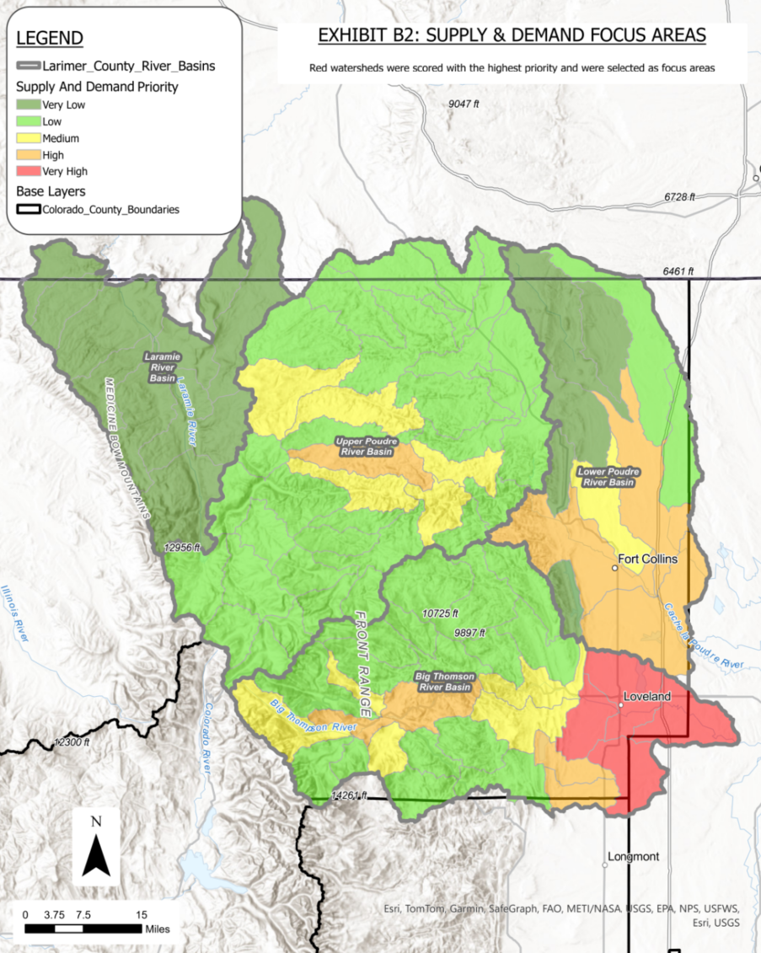

Exhibit B3

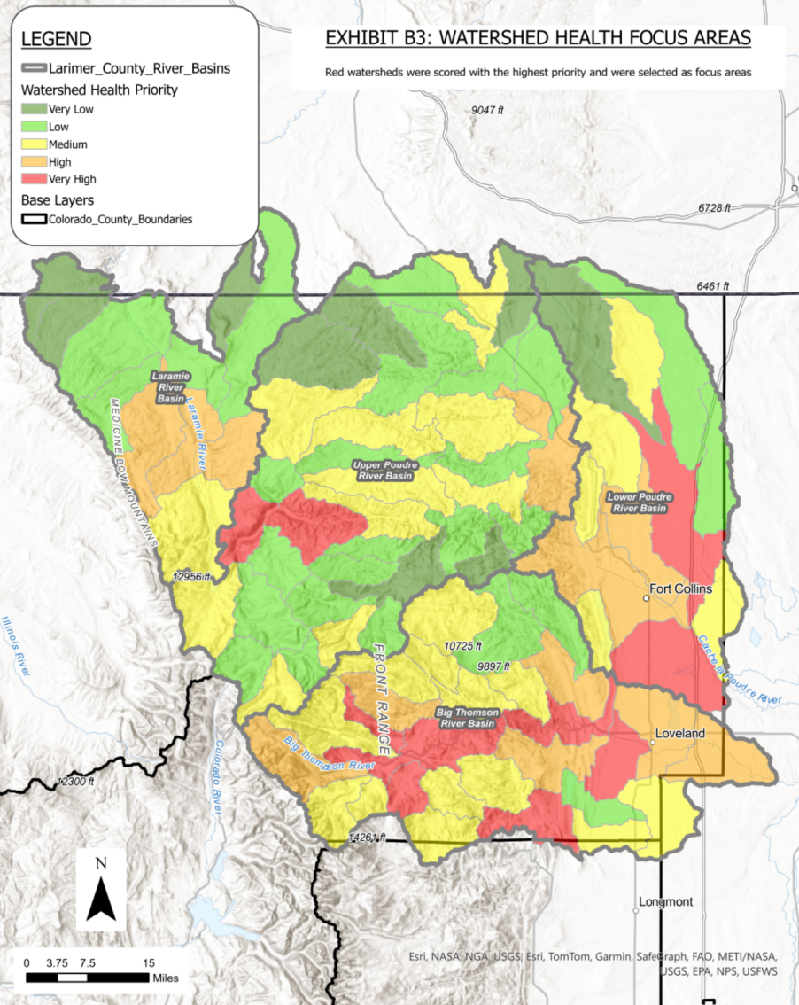

Exhibit B4

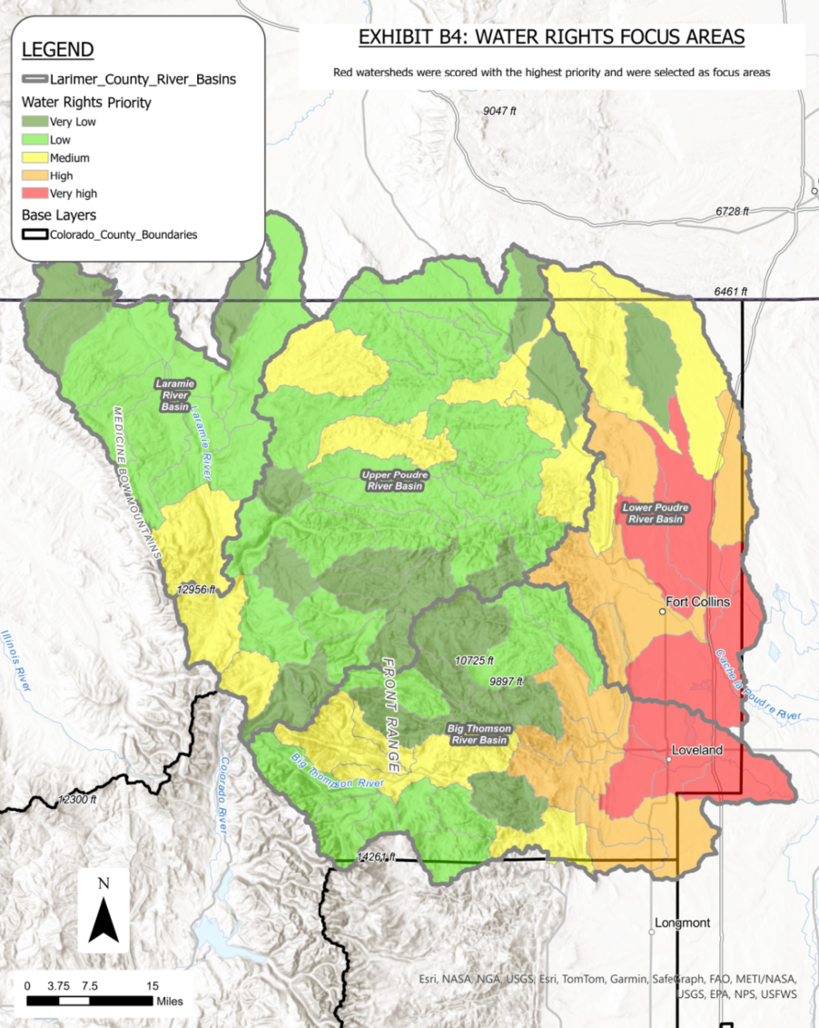

Exhibit B5

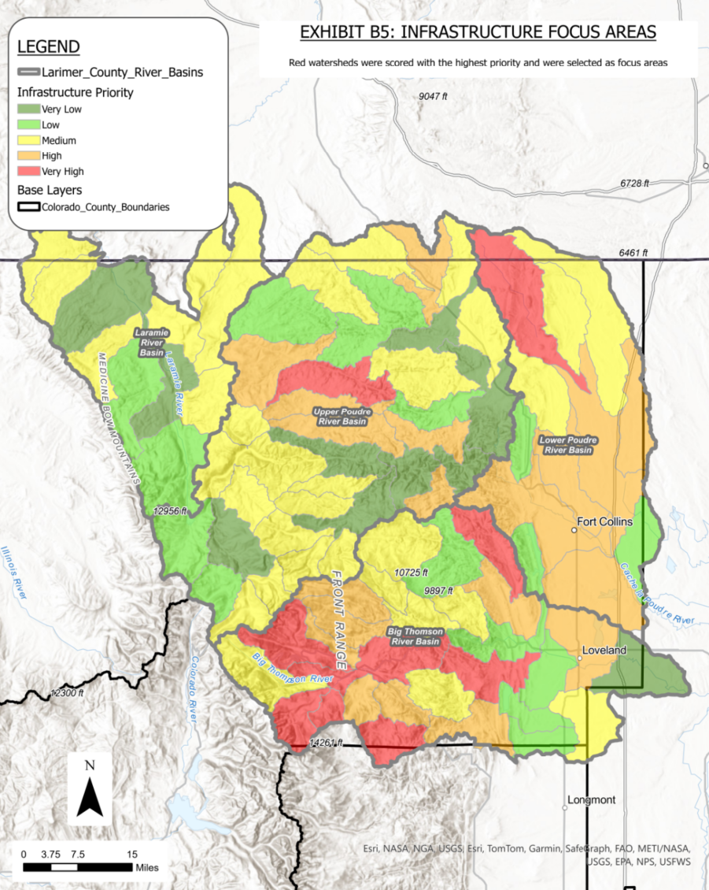

Exhibit B6

Table Ex.B6-1. Water Education Initiatives

|  |  |  |  |
| --- | --- | --- | --- |
| **Water Education Efforts** | | | |
| **Name of Initiative** | **Description** | **Contact Organization** | **Link to Website** |
| Project WET (Water Education Today) | Project WET is a program focused on K-12 water education. The Colorado Water Center is working on rebuilding its network of educators that has been depleted since the pandemic. | Colorado Water Center | <https://www.projectwet.org/> |
| Water Literate Leaders Program | In the past the County successfully partnered with the Colorado Water Center to promote/participate in the Water Literate Leaders Program. This program aims to engage community leaders in water conversations and solutions for Northern Colorado. | Colorado Water Center | <https://watercenter.colostate.edu/wll/> |
| Water Education Series | In the past the County successfully partnered with the Colorado Water Center to offer a water education webinar series on several water related topics | Colorado Water Center | https://watercenter.colostate.edu/larimer-county-water-education-series/ |
| Growing Water Smart Workshop | The Growing Water Smart Workshop offers opportunities for communities to consider how they can plan for future water supply and demand needs. | Northern Water Conservancy District/The Sonoran Institute | https://sonoraninstitute.org/events/colorado-growing-water-smart-workshop/ |
| Northern Water Education Events | Northern Water hosts several educational events for the public every year. They are also beginning a regional water messaging initiative that will be kicking off in the fall of 2024. They also have a goal to remove certain amounts of non-functional turf within their service area through education. | Northern Water Conservancy District | https://www.northernwater.org/in-the-community/education-and-outreach |
| Water Conservation Classes and Seminars | Resource Central offers free online waterwise yard seminars in the spring and summer, covering topics like turf removal, plant selection, and Colorado landscaping. Visit resourcecentral.org/seminars for upcoming and recorded sessions. They also host public conservation events, such as workshops and tours—check their calendar at resourcecentral.org/events for details. | Resource Central | [Waterwise Yard Seminars - Resource Central](https://resourcecentral.org/seminars/) |
| Water Education Colorado Programs | Water Education Colorado offers several programs, events and initiatives to build water leaders and educate the public. | Water Education Colorado | https://www.watereducationcolorado.org/programs-events/water-leaders/#/ |
| City of Fort Collins Education Programs | Fort Collins Utilities provides outreach and education for students and adults about our four utilities - water, wastewater, stormwater and electric. | City of Fort Collins | https://www.fcgov.com/utilities/education-programs |
| Colorado Waterwise Education Events | Colorado Waterwise hosts events and webinars every year to share the most recent best practices in water management. | Colorado Waterwise | [Colorado WaterWise - Educational Events](https://coloradowaterwise.org/Educational_Events) |

Table Ex.B6-2. Webinar Topic Suggestions

|  |  |  |  |
| --- | --- | --- | --- |
| **Potential Topics for Webinars/Water Education Series (Suggestions Gathered from Engagement Process)** | | | |
| **Topic Name** | **Potential Partner Organization** | | **Description** |
| Where Does Your Water Come From? | Local Water Providers | Multipart Series discussing transbasin diversions, key water sources, reservoirs, diversions, and interconnects that exist between water systems | |
| Water Conservation | Northern Water Conservancy District, other water providers, CSU | Review of current best practices in water conservation. Could be focused on plants, landscaping and building codes, or relevant research. | |
| Water and Agriculture | CSU Extension, U.S. Department of Agriculture | How Water gets to agricultural communities. What the water is used for. General review of daily farming/ranching operations. | |
| Land Use and Water Security Planning | Larimer County and Local Water Providers | Explaining the planning process for zoning and for coordinating with water providers on water adequacy letters. | |
| Water Quality and Habitat | Northern Water Conservancy District, Colorado Fish and Wildlife | Water quality monitoring systems, what we monitor for and why, success stories, stormwater quality applications, important species and habitats | |
| Wetlands and Riparian Areas | Larimer County Natural Resources, Colorado Department of Natural Resources | Review of the importance of wetlands and riparian areas and their role in keeping our water clean. | |
| Floodplains and Stormwater 101 | Colorado Water Conservation Board, Local Floodplain Consultants, Local Floodplain Administrator | Explanation of stormwater industry trends, best practices, FEMA flood risk 101, safety discussions regarding driving in flood conditions and how to design safer crossings and structures | |
| One Water Mentality | Local Water Providers | Understanding of best practices for integrating utility planning together | |
| The Role of Review Agencies | Local Municipalities, Larimer County, State Permitting Departments | Explanation of levels of authority and roles of the review process for several types of projects. Explanation of the 1041 process. | |
| Volunteer Opportunities | Colorado Water Center, Water Education Colorado | A review of all the opportunities for community members, businesses, and municipalities to get involved and support water education efforts. | |
| Water in the West | Northern Water Conservancy District, Colorado Division of Water Resources | Explanation of western water rights and how prior appropriation works. | |

Exhibit B7

Water Conservation Guidance and Water Conservation Resources

|  |  |  |
| --- | --- | --- |
| **Water Conservation Guidance Documents** | | |
| **Resource Name** | **Organization** | **Link to Resource** |
| Denver Water Residential page | Denver Water | [Conserve | Denver Water](https://www.denverwater.org/residential/rebates-and-conservation-tips) |
| CWCB Law & Policy page | Colorado Water Conservation Board | <https://cwcb.colorado.gov/public-information/law-and-policy> |
| CO Waterwise Best Practices Guidebook | Colorado Waterwise | <https://coloradowaterwise.org/BestPractices> |
| CSU Extension - Homeowner’s guide to water conservation | CSU Extension | <https://extension.colostate.edu/docs/pubs/consumer/xcm219.pdf> |
| Citizen’s guide to CO water conservation | Water Education Colorado | <https://www.watereducationcolorado.org/publications-and-radio/citizen-guides/citizens-guide-to-colorado-water-conservation/> |
| Northern Water - Water Efficiency Program | Northern Water Conservancy District | <https://www.northernwater.org/what-we-do/protect-the-environment/efficient-water-use> |
| Alliance for Water Efficiency | Alliance for Water Efficiency | <https://www.allianceforwaterefficiency.org/> |
| Fort Collins/Loveland Water District | Fort Collins/Loveland Water District | <https://fclwd.com/water/conservation/> |
| St Vrain/Left Hand Water Conservancy District | St Vrain/Left Hand Water Conservancy District | <https://svlhwcd.org/> |
| 21 Ways to Care for Colorado Water | Water Education Colorado | https://www.watereducationcolorado.org/get-involved/21-ways-to-care-for-colorado-water/#/ |

Appendix C  
  
Details on Selected Plan Strategies

*This page intentionally left blank.*

**Strategy cutsheets will be inserted into Appendix C during final document compilation**

Appendix D  
  
Additional Strategies Considered but Not Selected

| Challenge | Strategy Title | Strategy Description | Potential Actions |
| --- | --- | --- | --- |
| Supply and Demand Planning | **Water Security\*** | Enhance the coordination between the approval of land use applications and water providers. | >Confirm the legitimacy of water adequacy letters to ensure reliable water supply. >Align the zoning map with water provider service areas, paying attention to zoning types and locations with high demand uncertainty. >Involve water provider stakeholders in future zoning discussions. |
| **Climate Change Study** | Update the regional climate model to offer climate outlook data and assist smaller water providers in using it. | >Update a regional climate model/study to be able provide climate outlook data to water providers >Act as a partner/resource for smaller providers to utilize the model and have a more robust outlook on future water supply |
| **Water & Land Use Planning Tool** | Support the development of Polaris, a water and land use planning tool being created by the One Water Solutions Institute. | >Provide data and input into the model >Test some of the results and tools created >Stay involved in this effort |
| **Thoughtful Storage** | Address the concept that increasing water storage is one way to ensure water supply resilience. | >Educate the public about the benefits and challenges of reservoir projects, fostering informed community discussion and decision-making. >Streamline the process to increase water storage in Larimer County, assisting providers through the 1041 permitting process to enhance local water supply resilience. >Encourage collaborative projects that offer multiple benefits, such as combining water storage initiatives with environmental enhancements or recreational opportunities, fostering holistic community outcomes. |
| **Growing Water Smart\*** | Apply for and attend The Fall 2024 Growing Water Smart workshop. | >County team committed to attend sessions throughout the workshop’s duration. > Attend workshop to help rural and urbanizing communities integrate water and land use planning to better ensure their sustainability and resilience. |
| Watershed Health | **Water Quality Network Improvements** | Expand existing water quality projects, programs, and monitoring stations. | >Improve the water quality monitoring network (e.g., more stations, more sensors) >Improve data sharing between groups >Improve public’s understanding of water quality monitoring, potentially starting a citizen science initiative >Support Total Maximum Daily Load (TMDL) projects |
| **Habitat Protection Program\*** | Create a habitat protection program in and around waterways with a goal of protecting water quality. | >Improve setback regulations in and around waterways, wetlands, stream corridors, etc. >Improve the development review process to include a more stringent analysis in habitat protection on proposed applications. >Voluntary program for groups or individuals to protect habitats. |
| **Support to Watershed Health Groups\*** | Review, align with, and provide resources where possible with plans developed by watershed groups in the region. | >Funding and supporting partner for other entities’ plans/projects. >Collaborator for concurrent efforts the county is leading. |
| **Support Fuel Reduction\*** | Provide resources for partners who complete thinning and other fuels reduction projects. | >Assist in grant writing and reporting. >Provide resources, such as financial and labor resources, to carry out work. >Potential for program where Larimer County hires labor to carry out work - lot more resources needed. >Partner with State and Federal Agencies to support grazing on lands |
| **Larimer County Watershed Collaborative Group** | Convene the multiple working groups in Larimer County at a watershed scale to organize. | >Create a watershed health collaborative with reps from several organizations. >Schedule working meetings, networking opportunities, and provide a place to share progress and discuss projects |
| **Plug Abandoned Wells** | Work with State to plug abandoned oil and gas wells. | >Partner with state and other entities to identify location of abandoned wells, especially those with higher priority to plug. >Plug abandoned wells to stop contamination. >Remediate areas affected by abandoned oil and gas wells. |
| **Coexisting with Beavers** | Create a Beaver Adaptive Management Plan (like Mile High Flood District). | >Create a Beaver Adaptive Management Plan (like Mile High Flood District). >Recreate methods MHFD applied, this includes applying a beaver suitability and risk model to the stream system to identify reaches in which beavers may be suitable, reaches at high risk of beaver damage, and reaches to monitor adverse effects. |
| **Nutrient Trading Within the County** | Enhance nutrient trading options between agricultural and municipal providers. | >County to facilitate and support the exchange of nutrients so they don’t get to waste. >Water providers to give nutrients extracted from water quality treatment practices to agricultural community. >County to protect high quality soils during infrastructure and development projects |
| **Watershed-Wide Emergency Services Support** | Educate and support emergency staff on wildfire impacts to water quality. | More information is needed. |
| Water Education | **Student Education Opportunities** | Create educational programs and campaigns to promote water conservation and education to students. | >Develop programs that students and teachers can implement in their schools. >Support Project WET! (K-12 water education)  >Provide resources, support, staff, for University courses >Develop a messaging/marketing campaign around water conservation (kids to teach their parents) |
| **Support Utilities’ Education Efforts** | Provide resources and funding for partner’s educational programs. | >Provide resources and support for educational programs >Provide funding to expand residential sprinkler check-ups >Provide funding and resources to expand commercial sprinkler audits >Support Northern in their waterwise landscaping education, as well as their Land Use Code templates |
| **Parks and Open Space Education Programs\*** | Utilize Larimer County Parks and Open Space as a place to educate the public on water. | >Provide signage and education opportunities at Larimer County parks and open spaces about habitat and water quality |
| **Water Education Website** | Develop a comprehensive online water platform. | >Create an interactive map that shows water provider and irrigation company service areas.  >Provide information and resources on County website for people who are new to the area. >H2 info website (bring it back) >Develop a virtual messaging/marketing campaign around water conservation. |
| **County Led Public Education** | Create educational programs and campaigns to promote water conservation and education for all in the community. | >Continue water education, with topics like “Where does your water come from” or "water rights and water use" >Provide resources on water rights in Colorado >Host field trips within the County, such as brewery tours, or to CSU Spur Hydro >Educate citizen on the link between fire and water resources >Develop a messaging/marketing campaign around water conservation. |
| **Stakeholder Group Meetups** | Continue facilitating collaboration with stakeholders through round-table events. | >Continue working to bring entities together at round-table type events. >Invite all water providers to present and discuss at various meetings, events, potentially work sessions >Continue TAG/WAG style meetings (once or twice a year) >Clarify where County’s jurisdiction ends and where water court starts. |
| **Youth Education** | Support partners who work in youth education and provide resources around water. | >Partner w/ county extension office, 4-H program to expand water education to youth >Partner with other non-profits or youth camps and provide water education resources |
| **Water Exhibits & Festivals** | Support and bring awareness to upcoming events and exhibits. | >Support partners and provide resources to museums, festivals, libraries around water. For example, the Loveland children’s museum, CSU Spur Hydro, and the Children’s Water Festival |
| **Expand Water Literate Leaders Program\*** | Provide resources to expand the Water Literate Leaders Program through the Colorado Water Center. | >Expand the program to include members of the public |
| Water Rights | **Creation of Voluntary Agricultural Districts** | Create Voluntary Agricultural Districts that would limit the use of certain land to only agriculture, or a relevant land use as it relates to preserving water. | > County to Lead inquiries with Ag users to determine areas where users desire to form voluntary Ag districts > County to align zoning plan to protect these voluntary districts > Coordinate with Municipal partners to carry out similar efforts where applicable |
| **Improving Relationships near Agriculture and Urban interface\*** | County along with municipal partners to lead efforts in improving relationships between agricultural and urban residents in close proximity to one another. | > County with municipal partners to hold events to educate urban users on Agriculture operations, water use, and daily needs/processes > County could make other efforts related to an Ag use education campaign |
| **Statement on Protecting Native Water Supplies\*** | Developing an IGA or joint statement from the County and other governments willing to participate declaring intentions/desire to keep native county water supplies in-basin | > County to draft statement with help and input from municipal partners |
| **Protecting Natural Buffers Through Codes and Programs\*** | Using Land use code, zoning plans, and natural resources plans to preserve natural open space buffers between communities especially between urban and Ag lands | > Update Land Use codes to protect/ require natural buffers near waterways and agricultural land > Update zoning to create buffers around existing agricultural use and require it to stay in place during development review > Work these proposed natural buffers into the county’s natural resource plan. > Partner with municipalities to ensure the buffers created in unincorporated parts of the county remain protected and in place after areas are annexed into municipal boundaries |
| Infrastructure | **Supporting Utilities’ Capital Improvement Projects** | County should help fund/support capital projects from other entities, especially when those projects improve redundancy and interconnections between providers | > Get a list of Capital projects that need help with funding from all water providers in the county >Prioritize the List of projects based on importance/impact to county water supply and if redundancy/interconnectedness is improved as a result of the project. >Prioritize funding capital projects that smaller providers would have trouble funding on their own (this would include tribal potentially) >Offer to work with ditch companies to convert ditches to pipelines in areas that struggle with water efficiency. > Create a grant program that could issue funds every year to applicants. Scoring could prioritize redundancy and smaller providers. |
| **Funding Infrastructure Needs for Disproportionately Impacted Communities\*** | Counties to support water infrastructure upgrades for disproportionately impacted communities (such as mobile home parks) | > Use zoning maps and information from municipal partners to identify mobile home parks and other at-risk communities that are in need of infrastructure upgrades. > Help fund projects in incorporated areas > Lead projects in unincorporated Larimer County |
| Water Conservation | **Online Resources to Inform Residents about Water Efficiency\*** | Collaborate with municipalities and water providers on their existing programs.    Provide information and resources on the County website for people who are new to the area. | > Update website/create an interactive map explaining efficiency programs based on where residents live, what requirements exist, what programs are out there.  >Provide page on County website outlining best practices for water efficiency (faucets, and water fixtures as well as watersmart landscape designs). |
| **Update Larimer County Codes\*** | County should encourage passive conservation measures through land use and building code requirements such as efficient fixtures in buildings, certain acceptable/approved landscape types, higher density housing, etc. | >Review and update the Land Use Code as it relates to landscaping, higher density housing, etc. >Review and update the Building Code as it relates to efficiency in water fixtures. Look into adopting graywater into the code. > Potentially hire a consultant to implement land use and building code updates to incorporate water efficiency requirements for new and redevelopment, could also be down in house >Should base updates on best practices throughout the county |
| **Model/Template codes** | Provide Model Template Codes on the County website so that other providers/municipalities can reference/build upon. | > Support Northern Water, or other partners, in the creation of Model or Template Codes as it relates to water efficiency and conservation. >Provide these Model Codes on the County website for others to reference and/or build upon. |
| **Improve Water Efficiency in Landscapes\*** | County to improve water efficiency practices by providing resources to expand sprinkler checkup programs, and support opportunities to remove non-functional turf. | > Provide resources to other partners or engage with Larimer County Departments (like LCCC) to perform sprinkler audits on residential, commercial, and potentially industrial properties.  > Report audit results in a database of landowners > Create opportunities to remove non-functional turf within Larimer County |
| **Native plant demonstrations** | Host events focused on native plant demonstrations to educate both residents and technical staff/stakeholders. | >Partner with Northern water and/or CSU Spur campus to review native plant species and options for landscaping best practices. > Create a garden on County owned facilities where demonstrations can be provided |